CUB HOMEWORK and TEST Schedule

DATE DUE HOMEWORK TEST/QUIZZES

Tuesday Math Science
Language Arts History

Wednesday Math Math
History/Science

Thursday None Bible Unit Test

Friday Math Spelling
Language Arts Bible Verse
Language Arts

Language Arts encompasses Spelling, Reading and English.
* This is the typical framework I will follow, however, changes are subject to
occur.

Other 5th Grade Information

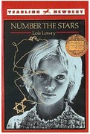
- Students will complete 2 novel units in 5th grade: Poppy by Avi and Number the Stars by Lois Lowry. I have some class readers, but not enough. Students will not be allowed to take them home. If you would like your child to have a personal copy, they will need them by the following dates: Poppy 9/17 and Number the Stars 2/25.
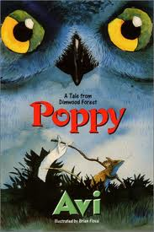

- 5th grade traditionally does a Blue/Gray competition every year. All students are divided into 2 teams, and they compete each Friday in a variety of physical, mental and crazy activities. Points are kept through the year based on t-shirts, winning, sportsmanship and following directions. The losing team will provide the food for our end of the year Blue/Gray party and cookout.

NOTE ABOUT CLASS READERS : If you purchase these books for your students, please send them in to school with your child’s name inside the book. We would discourage the students from reading the books before we do them in class, as it takes away from the excitement of discovering the book together!

